Meeting 32
Course / Class #: CECS 4800
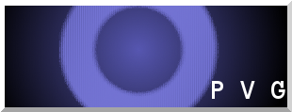
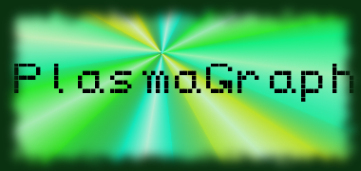
Date: 4 June 2014
Project Name: PlasmaGraph

Has been done:
- STD and SDD completed. (Automated tests originally missed were included,
- SRS fixed. (Had an organizational error.)
- User Manual and Installation Guide finished.
- All documents were presented to Advisor.
- Final Presentation created and performed for Advisor and Client.
- Code Documentation done.
- CDs prepared. (Waiting for Project Poster approval.)

What will be done:
- Present final product to Client and Plasma Laboratory Students.
- Work on poster. (Awaiting corrections for poster content.)
- Prepare CDs and deliver to Advisor and Client.

Materials Used: 2x Computers, Internet connections, OpenOffice Writer / Microsoft Word 2013 (Document-writing Tools), Eclipse / NetBeans IDE (Programming Tools).

Team Members: ________________________________
Gerardo A. Navas

________________________________
Daniel Quintini
Advisor:

________________________________
Prof. Luis A. Ortiz

